

DESTINATION

HOME

ABOUT US



FOLLOW US ON OUR

SOCIAL MEDIA ACCOUNTS!



**COPYRIGHT © 2022**

**HOME PAGE**

PHILIPPINE TOURIST SPOTS



The second-largest archipelagic country in the world after [Indonesia](https://www.touropia.com/best-places-to-visit-in-indonesia/" \t "https://www.touropia.com/explore/philippines/_blank), the Philippines has everything you could ever want from a holiday destination. Besides [idyllic islands](https://www.touropia.com/best-islands-in-the-philippines/" \t "https://www.touropia.com/explore/philippines/_blank) and breathtaking beaches, it has lush rainforests, soaring volcanoes and colorful coral reefs, while its quiet colonial towns and teeming megacities exhibit a wide array of cuisines and cultures.

Set in Southeast Asia, the enormous archipelago consists of around 7,640 islands with only roughly a third of them being inhabited. Surrounded by the shimmering waters of South China, Celebes and Philippine seas, it remarkably boasts the fifth-longest coastline in the world. Dazzling white sands are set alongside gently swaying palm trees and tantalizing turquoise lagoons. Very mountainous and biodiverse, its two largest and most populous islands are those of Luzon and Mindanao.



DESTINATION

HOME

ABOUT US



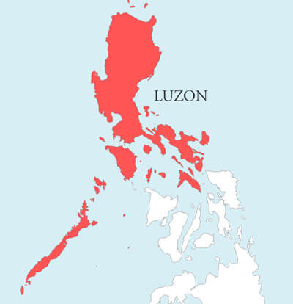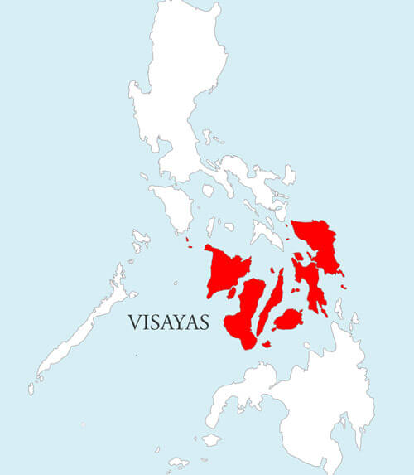

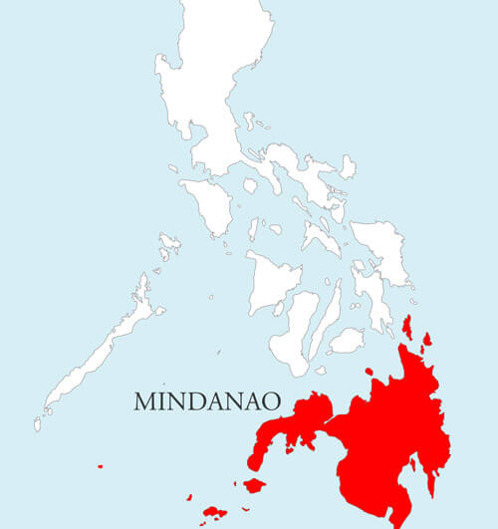



FOLLOW US ON OUR

SOCIAL MEDIA ACCOUNTS!



**COPYRIGHT © 2022**

**DESTINATION PAGE**



DESTINATION

HOME

ABOUT US



CONTACT US

If you have any comments, or suggestion, you may send us an email at ***touropiaph@gmail.com.***

We love to hear your thoughts, and thank you for reading our blog. We really appreciate it!



FOLLOW US ON OUR

SOCIAL MEDIA ACCOUNTS!



**COPYRIGHT © 2022**

**ABOUT US PAGE**



DESTINATION

HOME

ABOUT US

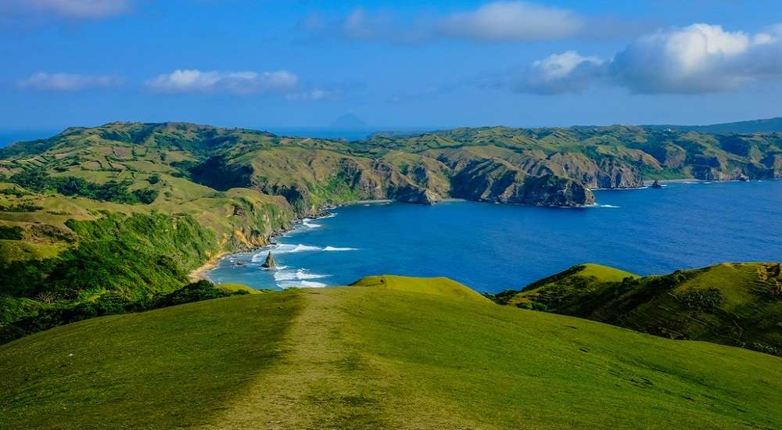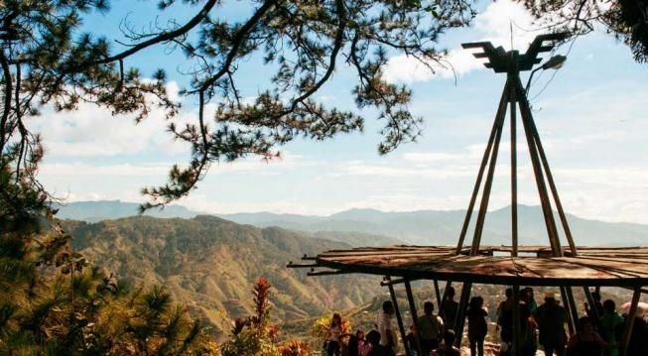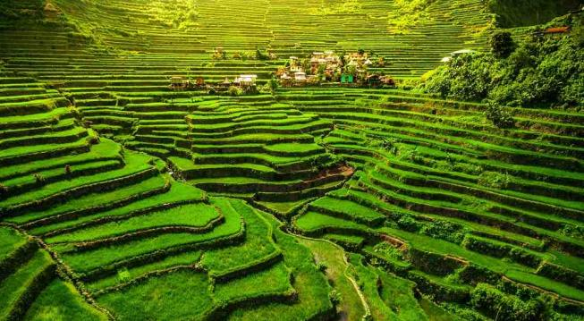

One of the places to visit in Luzon that will take your breath away is Banaue Rice Terraces. Locally known as the Hagdan-Hagdang Palayan, this beautiful spot in Luzon is undoubtedly a source of pride not just for the Ifugaos but also for Filipinos across the world. Because of its magnificence, it has been inscribed on the [UNESCO World Heritage List](http://52.221.46.96/post/unesco-world-heritage-sites-philippines/" \t "https://www.zenrooms.com/blog/luzon-tourist-spots/_blank) in 1995.

**BANAUE RICE TERRACES**

No doubt, the most famous [tourist spot sa Baguio](http://52.221.46.96/post/baguio-tourist-spots/" \t "https://www.zenrooms.com/blog/luzon-tourist-spots/_blank) is Mines View Park because of the great view it offers. In the early 20th century, Baguio was a mining town. Mines View Park sits on a ridge of the northeast side of Baguio where you can see a stunning view of the Cordillera Mountains and Benguet’s old copper and gold mines.

**MINES VIEW PARK**

See more

**RACUH A PAYAMAN**



FOLLOW US ON OUR

SOCIAL MEDIA ACCOUNTS!



**COPYRIGHT © 2022**

**LUZON PAGE**



DESTINATION

HOME

ABOUT US



DESTINATION

HOME

ABOUT US



Oh, Boracay. Does this island even need an introduction? [Boracay](http://52.221.46.96/post/boracay-tourist-spots/" \t "https://www.zenrooms.com/blog/visayas-tourist-spots/_blank) is not just a famous Western Visayas tourist spot but it’s popular all over the world. What makes travelers visit this island paradise is, well…a lot! From the finest white sand, cerulean waters, fun water activities, and amazing nightlife, Boracay will surely captivate you.

**BORACAY - AKLAN**

Located in the town of Lazi in Siquijor, Cambugahay Falls is considered one of the most [beautiful waterfalls in the Philippines](http://52.221.46.96/post/waterfalls-in-the-philippines/" \t "https://www.zenrooms.com/blog/visayas-tourist-spots/_blank). Cambugahay Falls is a catch for tourists because of its turquoise clean and warm water originating from natural springs. Its water will invite you to plunge in, the moment you see it. If you want a more thrilling experience, jump on the cliff there or dive into the waters using the swing.

**CAMBUGAHAY FALLS - SIQUIJOR**

See more

**CHOCOLATE HILLS - BOHOL**

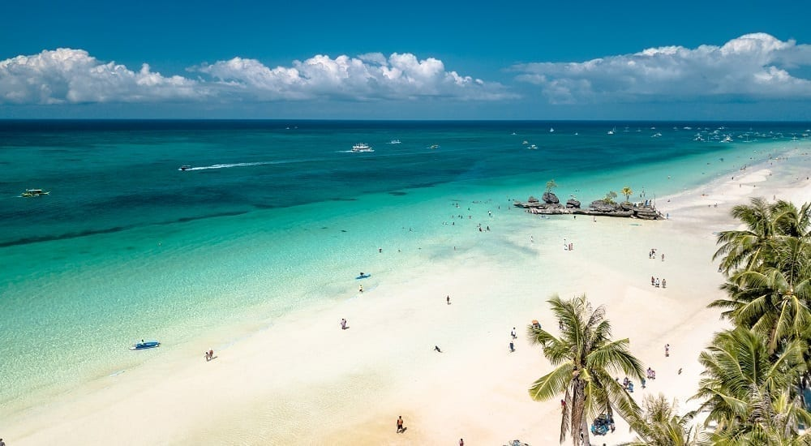



FOLLOW US ON OUR

SOCIAL MEDIA ACCOUNTS!



**COPYRIGHT © 2022**

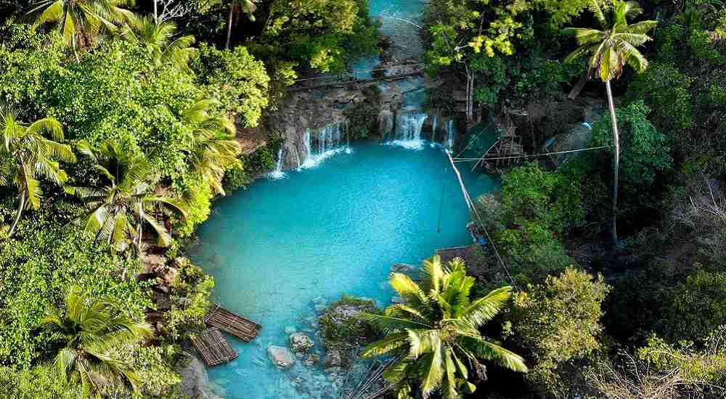

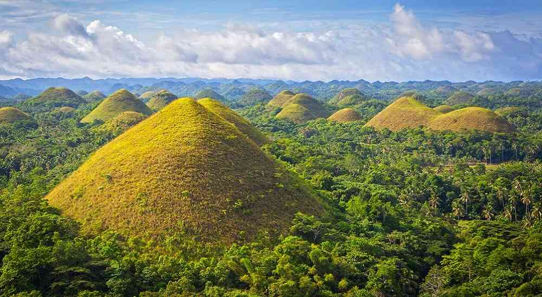

**VISAYAS PAGE**



DESTINATION

HOME

ABOUT US



Dubbed as the “King of Philippine Peaks,” Mt. Apo is the highest mountain in the Philippines and among the highest in Southeast Asia standing at 10,311 feet. This Davao City tourist spot is a must-visit especially if you’re looking for a thrill adventure. There are different trails you can take and there are seven different peaks at the summit where you can see scenic views–from the majestic sunrise and sunset, to the magical sight of seeing the ground touching the sky.

**MOUNT APO**

When you see a photo of a traveler on the roadside with thousands of coconut trees in the background, you know it’s in Siargao. You can also head to the famous street where you’ll see hundreds of coconut trees lined up on both sides of the road that make a perfect IG spot! Don’t miss this tourist destination in Mindanao if you want a feed-worthy photo.

**COCONUT MOUNTAIN VIEW**

See more

**HINATUAN ENCHANTED RIVER**

**MINDANAO PAGE**

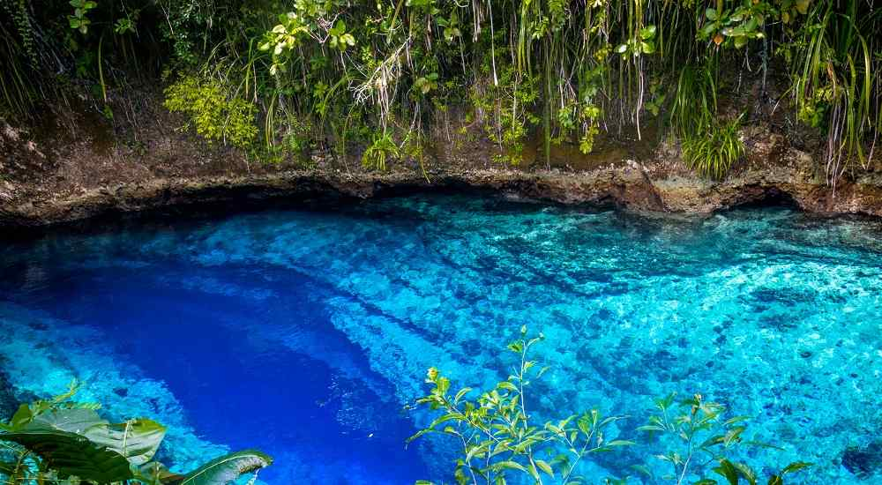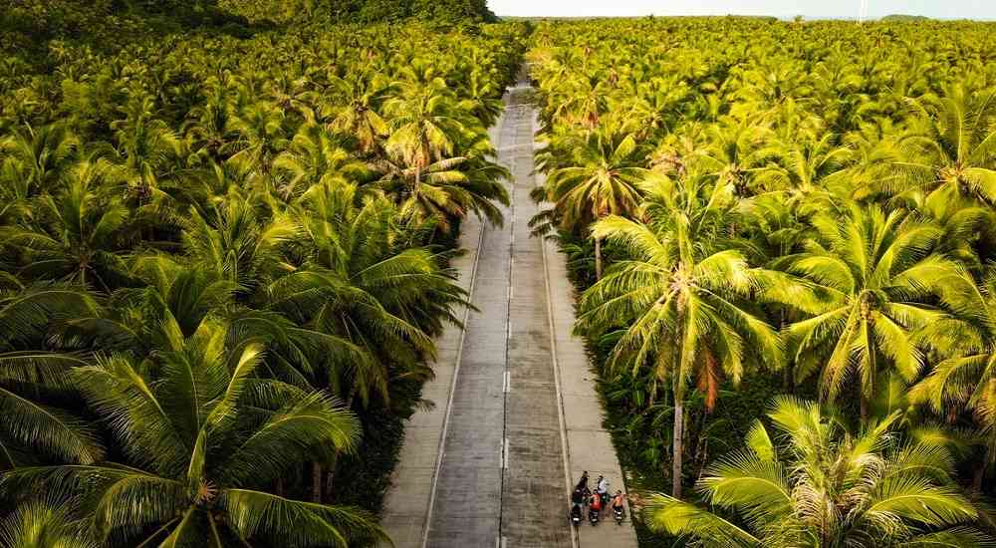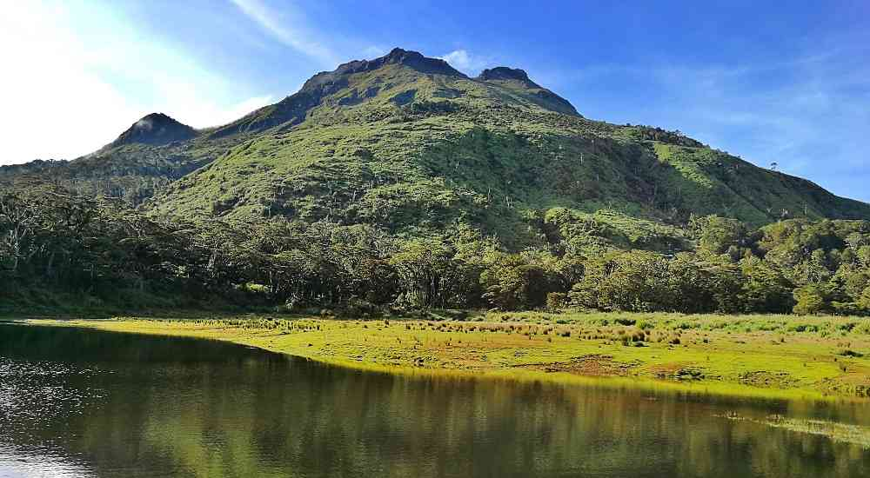



FOLLOW US ON OUR

SOCIAL MEDIA ACCOUNTS!



**COPYRIGHT © 2022**